Body Sculpt App – Project 3 Overview
Project Summary
The Body Sculpt App is a full-stack application designed to help users track workouts, meals, and nutrition data. Project 3 focuses on integrating a frontend client with the backend REST API developed in earlier projects. The frontend allows users to interact with the system through a web interface while communicating with the backend via HTTP requests.

Objectives of Project 3
- Develop a frontend client using HTML, CSS, and JavaScript
- Connect the frontend to the backend REST API
- Ensure proper JSON communication between client and server
- Implement full CRUD operations through the UI
- Validate correct data flow between frontend, backend, and database

AI Prompt
In previous chats labeled: Branch · Full Stack - CSCE 548 – Project and CSCE 548 - Project 2 Development, you helped me complete phase 1and 2 of my project. The instructions for phase 1 and 2 are included in attached images. These are the instructions I gave you to help me complete phase 1:
Help me complete the first phase of my semester long project with step by step instructions. C++ will be the programming language of choice. My project idea is a body sculpting app that keeps track users' workout and diet details in order to help them sculpt the body of their dreams.
These are the instructions I gave you to help me complete phase 2:
Now, I want you to help me complete phase 2 of my project. I would also like to add the optional logging functionality. The instructions, ERD, and solution explorer (showing how the app's files are organized) are also included in the attached images.
Now, I want you to help me complete phase 3 of my project. The instructions for all of the different phases, ERD, and solution explorer (showing how the app's files are organized) are also included in the attached images.
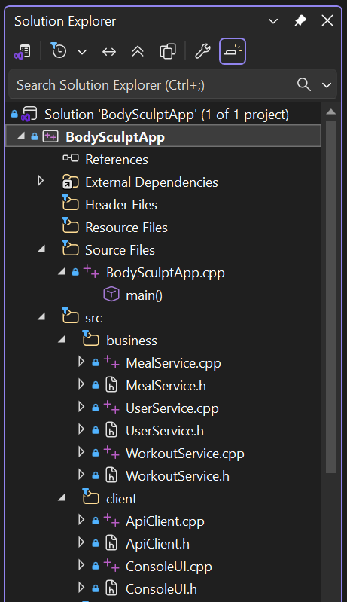
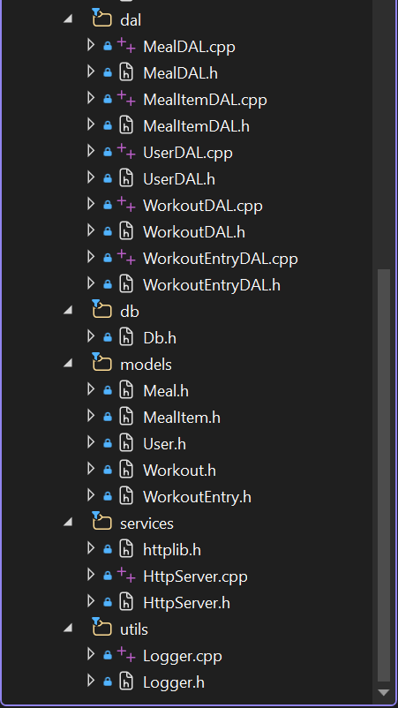
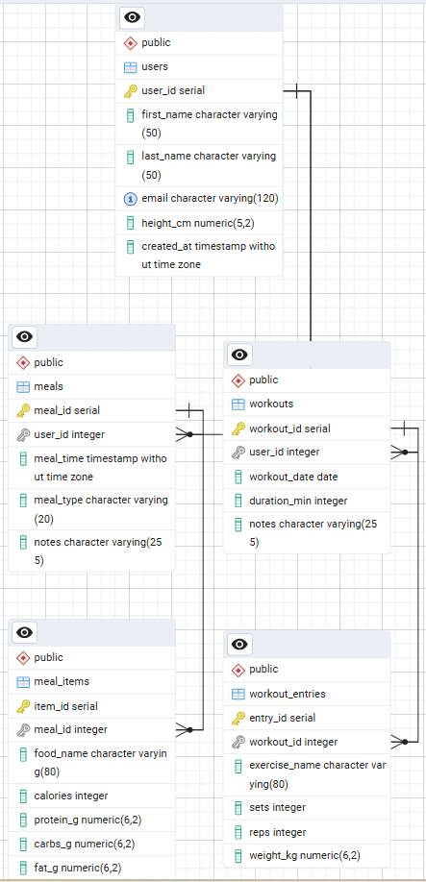
NOTE: The missing screenshots are the screenshots of the Project 1, Project 2, and Project 3 instructions.

System Architecture
Frontend
- Built using:
  - HTML (structure)
  - CSS (styling)
  - JavaScript (logic and API calls)
- Provides user interface for:
  - Users
  - Workouts
  - Workout Entries
  - Meals
  - Meal Items
Backend
- Developed in C++ using an HTTP server
- Handles REST API endpoints:
  - /users
  - /workouts
  - /workouts/{id}/entries
  - /meals
  - /meals/{id}/items
- Returns responses in JSON format
Database
- PostgreSQL database
- Tables:
  - users
  - workouts
  - workout_entries
  - meals
  - meal_items
- Uses foreign key relationships for data integrity

Frontend–Backend Integration
Same-Origin Setup
To avoid CORS issues, the frontend is served directly from the backend server using the /ui route:
http://localhost:8080/ui/index.html
This ensures:
- No CORS errors
- Seamless communication between frontend and backend

API Communication
The frontend uses JavaScript fetch() to communicate with backend endpoints.
Example:
fetch("/users", {
method: "POST",
headers: { "Content-Type": "application/json" },
body: JSON.stringify(userData)
});

JSON Handling
- Requests are sent as JSON
- Responses are returned as JSON
- Field names between frontend and backend are consistent:
  - first_name
  - last_name
  - email
  - height_cm

Implemented Features
Users
- Add user
- Get user by ID
- Get all users
- Update user
- Delete user
Workouts
- Add workout
- Get workouts
- Update workout
- Delete workout
Workout Entries
- Add entries to workouts
- Retrieve entries by workout ID
Meals
- Add meal
- Get meals
- Update meal
Meal Items
- Add meal items
- Retrieve items by meal ID
- Update and delete items

Testing Process
Testing was performed in the following order to respect database relationships:
- Users
- Workouts
- Workout Entries
- Meals
- Meal Items
Testing Methods
- Frontend UI interactions
- Browser DevTools (Network tab)
- Backend logs (app.log)
- Database verification using PostgreSQL

Key Challenges and Solutions
1. CORS Errors
- Issue: "Failed to fetch" due to cross-origin requests
- Solution: Serve frontend from backend (/ui route)
2. File Path Issues
- Issue: Frontend files not found by backend
- Solution: Corrected absolute path to frontend directory
3. Route Errors (404)
- Issue: Incorrect URLs (e.g., .htm vs .html)
- Solution: Standardized routes and verified endpoints
4. JSON Field Mismatch
- Issue: Frontend and backend field names differed
- Solution: Aligned all field names consistently

Results
- Frontend successfully communicates with backend
- All CRUD operations function correctly through UI
- Data persists correctly in PostgreSQL database
- Application runs without runtime errors

Conclusion
Phase 3 successfully integrates the frontend client with the backend system, enabling full user interaction through a web interface. The application demonstrates proper RESTful design, database integration, and real-world full-stack functionality.

Future Improvements
- Add authentication and user login
- Improve UI/UX design
- Add input validation and error handling
- Implement pagination and filtering
- Deploy application to a cloud environment

How to Run the Application
- Start the backend server in Visual Studio
- Ensure PostgreSQL is running
- Open the frontend at:
http://localhost:8080/ui/index.html
- Use the UI to perform CRUD operations

